**AGRO ASSIST**

Agro Assist is a Mobile Application targeted at promoting Educating Farmers and also creating a market place for Buyers and Sellers of Agricultural products. Agro Assist aims to assist the achievement of SDG’s 1 and 2 which are “No Poverty” and “No hunger” this is achieved by creating a market place there by enpowering local small scale farmers and large scale farmers alike to create revenue from farming. Also Agro Assist explicitly teaches with demonstration various areas of Agriculture, making easy for anyone to start up a farm regardless of how small the farm may be.

The Mobile App consist of the following features:

1. The home page where users can find products and sellers in various categories

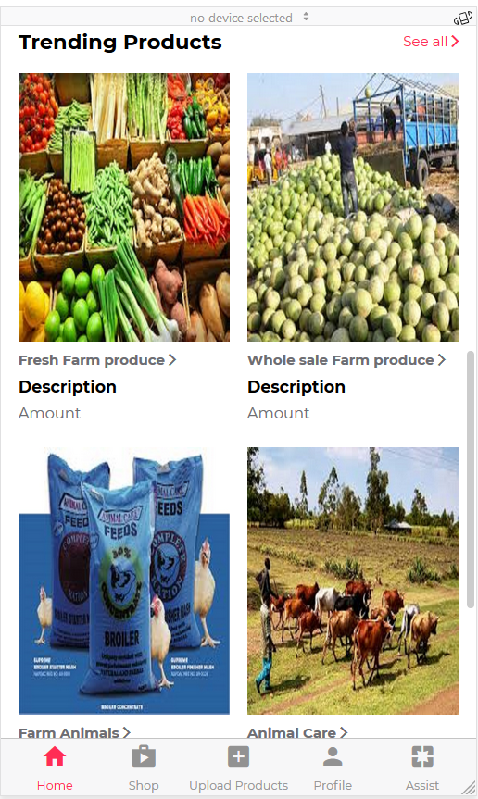 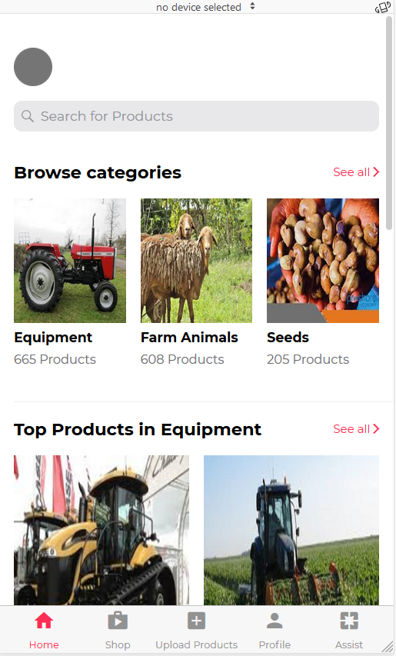

1. A sign up and login page for users to create an account

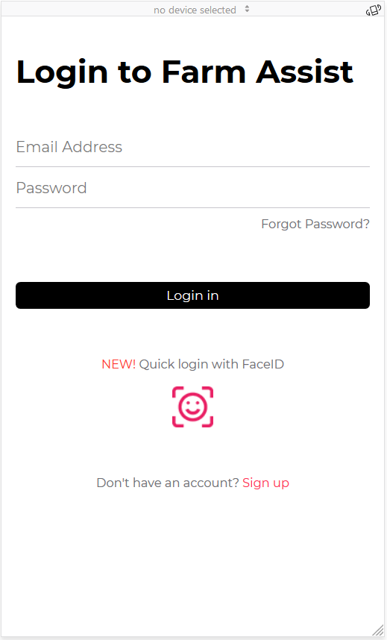 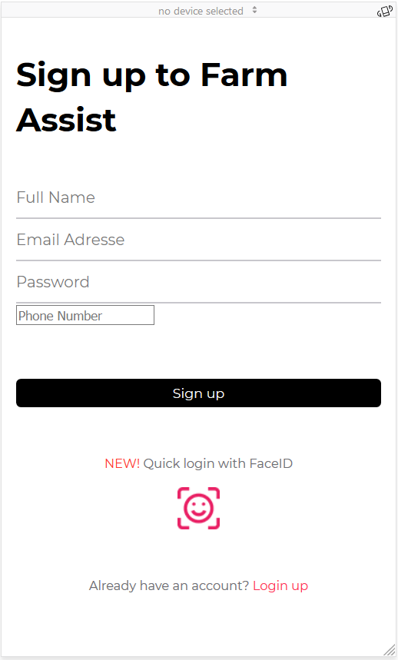

1. A profile account where users can update their contact detail, information and also all personally uploaded products.
2. The shop option shows a comprehensive list of all uploaded products

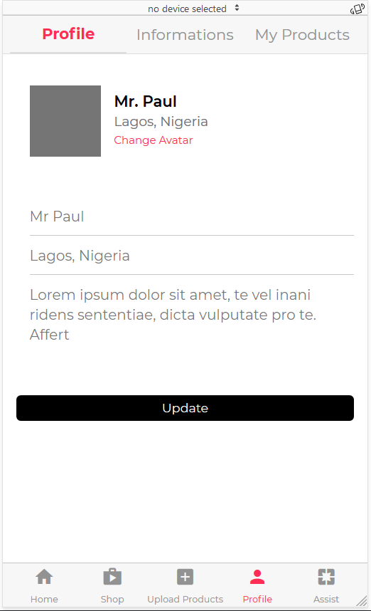 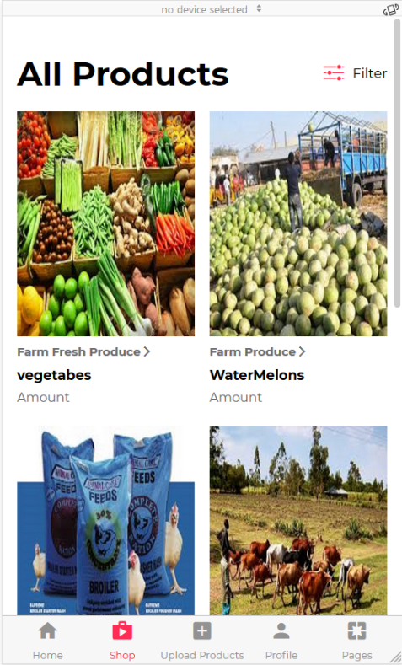

The Mobile Application also has a LEARN section that teaches users all about Farming, Agricuture and the best practices to help users through starting up a farm to final consumer as the case may be.

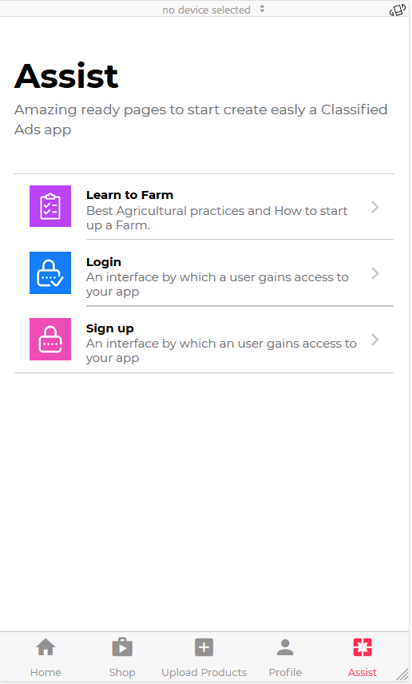

A later Version will have an integrated USSD option and Weather Forecast Section to assist farmer during planting seasons .